Equality Impact Assessment (EqIA) December 2022

You will need to produce an Equality Impact Assessment (EqIA) if:

- You are developing a new policy, strategy, or service
- You are making changes that will affect front-line services
- You are reducing budgets, which may affect front-line services
- You are changing the way services are funded and this may impact the quality of the service and who can access it
- You are making a decision that could have a different impact on different groups of people
- You are making staff redundant or changing their roles

Guidance notes on how to complete an EqIA and sign off process are available on the Hub under Equality and Diversity.
You must read the guidance notes and ensure you have followed all stages of the EqIA approval process (outlined in appendix 1).
Section 2 of the template requires you to undertake an assessment of the impact of your proposals on groups with protected characteristics. Equalities and borough profile data, as well as other sources of statistical information can be found on the Harrow hub, within the section entitled: Equality Impact Assessment - sources of statistical information.

Equality Impact Assessment (EqIA)

Type of Decision:
Title of Proposal | Approve the Youth Justice Annual Plan | Date EqIA created: 20 Sep 2023
Name and job title of completing/lead Officer | Mark Scanlon – Assistant Director of Harrow Youth Justice & Early Help Service
Directorate/ Service responsible | People > Children and Families
Organisational approval
EqIA approved by the EDI Team: | Name: Jennifer Rock  Assistant Policy Officer – EDI Team | Signature  ☒  Tick this box to indicate that you have approved this EqIA  Date of approval: 27.09.23

- Summary of proposal, impact on groups with protected characteristics and mitigating actions
(to be completed after you have completed sections 2 - 5)
a) What is your proposal?
The Annual Plan is a government requirement. It outlines the strategy and arrangements of fulfilling the Statutory Duty outlined at Section 39 of the Crime and Disorder Act 1998 to establish suitable Youth Justice Services and partnership arrangements in a local authority area. The proposal is for Council to approve the annual plan which outlines the arrangements and strategies in place to fulfil this requirement.

b) Summarise the impact of your proposal on groups with protected characteristics

The Annual Plan includes a strategic objective to address the over representation of young Black men within the criminal justice system. This is a pattern which is evidenced at National, London and Harrow wide level. The inclusion of a priority to address this aims to reduce such over-representation.

c) Summarise any potential negative impact(s) identified and mitigating actions

No negative impacts have been identified

2. Assessing impact
You are required to undertake a detailed analysis of the impact of your proposals on groups with protected characteristics. You should refer to borough profile data, equalities data, service user information, consultation responses and any other relevant data/evidence to help you assess and explain what impact (if any) your proposal(s) will have on each group. Where there are gaps in data, you should state this in the boxes below and what action (if any), you will take to address this in the future. |  | What does the evidence tell you about the impact your proposal may have on groups with protected characteristics? Click the relevant box to indicate whether your proposal will have a positive impact, negative (minor, major), or no impact
Protected characteristic | For each protected characteristic, explain in detail what the evidence is suggesting and the impact of your proposal (if any). Click the appropriate box on the right to indicate the outcome of your analysis. | Positive impact | Negative  impact |  | No impact
 |  |  | Minor | Major
Age | Harrow has a resident population of 261,300 . Increasing by 9.3% in the ten years between 2011 and 2021 with an increase of 7.8% in people aged 15 to 64 years, It has an above average working age population aged 16-64 of just under 64% (160,462) and a growing younger population aged 0-15 of 18.5% (48,300), which is higher than the London average, suggesting that the borough is a popular destination for families.  - As with most areas in the country, the borough has an ageing population. With the number of residents aged 65 plus Increasing by 19.4% in the ten years between 2011 and 2021 with 31% rise in people aged 90 years and over. Those aged 85 plus could increase by 60% by 2030.  - Data available shows that the pandemic has adversely impacted young people aged 18-24, with 1 in 10 young people out of work.  - Harrow has one of the lowest proportions of young people Not in Education, Employment and Training (NEETS). However, due to the Covid-19 pandemic, there has been a significant increase in numbers, from 0.8% to 1.8%. (Now 1.2% August 2022)  Impact  The projects will aim to be inclusive of all residents regardless of their age as it is a statutory obligation for the council to maintain a Youth Justice Service | ☐ | ☐ | ☐ | ☒
Disability | - The 2021 Census data shows that 9.75% of Harrow’s population aged 15 to 64 years have a disability this equates to 16,840 people.  - There is a strong correlation between disability, in particular the extent of the disability, and economic inactivity.  - There are also particular groups that have specific obstacles in progressing to the labour market or sustaining self-employment. These include adults with learning disabilities and those with severe mental health issues.  - Disabled people are also likely to be under-represented among business owners within Harrow.  Impact  The Youth Justice Service aims to be inclusive of all residents regardless of their disability status. scheme | ☐ | ☐ | ☐ | ☒
Gender  reassignment | - In 2020, the Equality and Human Rights Commission (EHRC) survey found that one in six respondents identified themselves as prejudiced towards transgender people.  - There is limited national data collected for this characteristic. We will need to consider the inequalities and discrimination experienced for this protected group when data becomes available.  - The charity Gender Identity Research & Education Society (GIRES) estimated in their Home Office funded study in 2009 the number of transgender people in the UK to be between 300,000 and 500,000. More recently Stonewall advised that it is estimated that around 1% of the population might identify as trans, including people who identify as non-binary. This would represent about 600,000 trans and non-binary people in Britain and about 2,500 people in Harrow.  Impact  - The Youth Justice Service will be inclusive of all residents regardless of their gender reassignment status. | ☐ | ☐ | ☐ | ☒
Marriage and Civil Partnership | - At the time of the 2021 Census 53.9% of Harrow's residents were married or in a registered civil partnership, which was the highest level in London.  - 21% of households were married, or in same-sex civil partnerships, with dependent children, the highest level in London.  - At October 2020 there have been 144 Same Gender Civil Partnerships in Harrow, 25 of which has been converted to a Marriage. There have been 8 Opposite Gender Civil Partnerships. There have been 57 Same Sex marriages.  of households in Harrow  LAD  are  single-family households of a married or civil partnership couple with dependent children  Impact  The projects will be inclusive of all residents regardless of their marriage and partnership status.Census | ☐ | ☐ | ☐ | ☒
Pregnancy and Maternity | - ONS births figures show Harrow as having 3,312 live births in 2021. 14 live births per 1000 population is higher than the England & Wales average of 10.8  - The borough has a higher-than-average infant mortality rate in London, at a rate of 3.9 deaths per 1000 live births, which is an indicator of poverty and inequality in the borough.  - Nationally, women have faced discrimination during pregnancy and maternity in the workplace. EHRC Survey data shows that around one in nine mothers (11%) reported that they were either dismissed; made compulsorily redundant, where others in their workplace were not.  Impact  The projects will be inclusive of all residents regardless of their pregnancy and maternity status, including residents with childcare/caring responsibilities. | ☐ | ☐ | ☐ | ☒
Race/  Ethnicity | 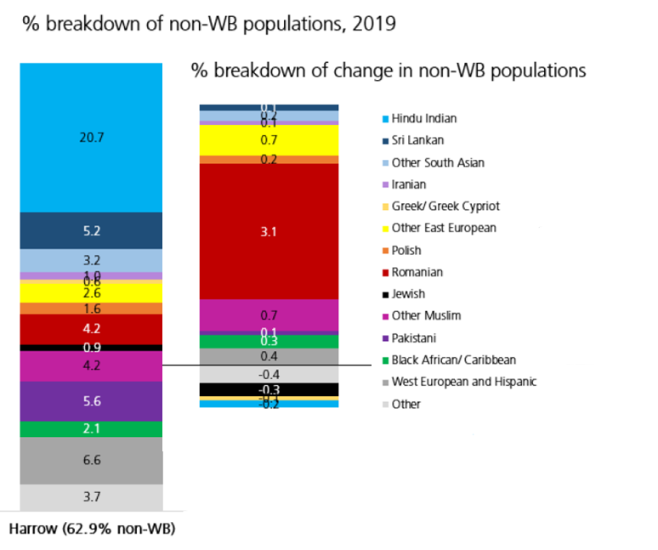  - Harrow is one of the most culturally diverse local authorities in the UK, with over 60% of residents from Black, Asian, and Multi-Ethnic backgrounds and an estimated 20% Eastern European community, which is fast growing. Black African (notably the Somali Community) groups have been fast growing over the last 6 years or so, as has the Afghan community.  - Unemployment rates are significantly higher in certain areas of the borough, particularly in the Wealdstone and Marlborough area (central Harrow) and  Roxbourne (south Harrow), focused in an around the Rayners Lane estate and among residents classified as Black and Other ethnic groups. These areas are also ranked high on the indices of deprivation for the UK. | ☒ | ☐ | ☐ | ☐
Race/  Ethnicity continued | - The majority of 16–18-year-olds that are classed as NEET are from Black and Multi Etnic backgrounds and located in neighbourhoods with high levels of deprivation. However, the data also shows that the single largest ethnic group of pupils aged 16-18 classed as NEET is White British.  - Marlborough, and Wealdstone neighbourhoods have the highest number of households in need of re-housing. These respectively have a Black and Multi Etnic population of 77% and 75%.  - The highest rates of overcrowding is in Greenhill ward (97.5 per 1,000 households) and a Black and Multi Etnic population of 74% (2011 census).  - Over 94% of Harrow businesses are classed as micro-businesses. There is limited data on the profile of business ownership by protected characteristics. Anecdotal evidence suggests that most retail businesses in Harrow’s town centres are Black and Multi Etnic - owned.  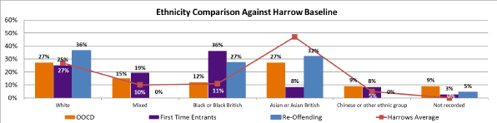  Impact  The Youth Justice Service will aim inclusive of all residents regardless of their race and ethnicity and explicitly anti-racist in attempting to address the known disproportionality of young Black men overly represented in the criminal justice system. | ☐ | ☐ | ☐ | ☒
Religious diversity | - Religious diversity is strong in Harrow. At the 2011 Census Harrow was the most religiously diverse borough in the country with the highest number Hindus (25%) and Jains (2.2%) and the second highest number of Zoroastrians.  - At the 2021 census Harrow had the highest number (and proportion) of Hindu followers in the country (25.8%). At 2.8% Harrow 's Jewish community was the nineth largest nationally. 33.9% of residents described themselves as Christians (the 11th lowest proportion in the country) and 15.9% described themselves as Muslims. Harrow had the lowest ranking for ‘no religion’ (10.9%).  - As the population’s ethnic composition changes, rates of participation in various religions are also likely to change.  - There is limited data on employment/unemployment rates for Harrow by religion.  Impact  The Youth Justice Service will aim to be inclusive of all residents regardless of their religion or beliefs. | ☐ | ☐ | ☐ | ☒
Sex | - The 2021 census show that the total population of Harrow is now 261,300, made up of 132,500 women (50.7%) and 128,800 men (49.3%). Overall, the number of males and females living in Harrow is very similar.  - Economic activity among Harrow’s male population is higher than the London average at 86%, compared with 83%. However, economic activity among females in the borough is lower than the London average at 72%.  - Harrow is a low wage borough, with those that are employed in the borough earning less than the London average weekly earnings of £813.40. Women also earn less than men in the borough. The average gross weekly earnings among women working in Harrow is £480.10, this is 28% lower than the London average of £666.  - 20% of Harrow businesses are female led.  - While the pandemic may have negatively impacted both sexes, the shift to home working may have had a positive impact in enabling women to return to work, as they are able to share childcare responsibilities.  Impact  The Youth Justice Service will be inclusive of all residents regardless of their sex. | ☐ | ☐ | ☐ | ☒
2.1 Cumulative impact – considering what else is happening within the Council and Harrow as a whole, could your proposals have a cumulative impact on groups with protected characteristics?
☒ Yes No ☐

Black young men are over represented nationally already within the criminal justice system. The Harrow Youth Justice Service aims to address this through a 3 pronged anti-racist approach
- Train all team members in anti-racist and unconscious bias approaches
- Provide leadership and resilience building programmes for children already within the system to help them understand the structural context and how to overcome the pernicious impact of structural biases
- Challenge all partners and providers to develop their own cultural competence and understanding of structural and entrenched forms of endemic racist systemic arrangements

2.2 Any other impact - considering what else is happening nationally/locally (national/local/regional policies, socio-economic factors etc), could your proposals have an impact on individuals/service users, or other groups?
☐ Yes No ☒
If you clicked the Yes box, Include details in the space below

3. Actions to mitigate/remove negative impact
Only complete this section if your assessment (in section 2) suggests that your proposals may have a negative impact on groups with protected characteristics. If you have not identified any negative impacts, please complete sections 4 and 5.

In the table below, please state what these potential negative impact (s) are, mitigating actions and steps taken to ensure that these measures will address and remove any negative impacts identified and by when. Please also state how you will monitor the impact of your proposal once implemented.
State what the negative impact(s) are for each group, identified in section 2. In addition, you should also consider and state potential risks associated with your proposal. | Measures to mitigate negative impact (provide details, including details of and additional consultation undertaken/to be carried out in the future). If you are unable to identify measures to mitigate impact, please state so and provide a brief explanation. | What action (s) will you take to assess whether these measures have addressed and removed any negative impacts identified in your analysis? Please provide details. If you have previously stated that you are unable to identify measures to mitigate impact please state below. | Deadline date | Lead Officer
n/a

4. Public Sector Equality Duty
How does your proposal meet the Public Sector Equality Duty (PSED) to:
- Eliminate unlawful discrimination, harassment and victimisation and other conduct prohibited by the Equality Act 2010
- Advance equality of opportunity between people from different groups
3. Foster good relations between people from different groups

Include details in the space below

The relevant priority within the Annual YJ Plan aims to promote greater equality of representation within the criminal justice system.

The YJ plan aims to promote greater equality of outcome for all young people at risk of being impacted by the criminal justice system as a whole.

5. Outcome of the Equality Impact Assessment (EqIA) click the box that applies
☒ Outcome 1
No change required: the EqIA has not identified any potential for unlawful conduct or disproportionate impact and all opportunities to advance equality of opportunity are being addressed

☐ Outcome 2
Adjustments to remove/mitigate negative impacts identified by the assessment, or to better advance equality, as stated in section 3&4

☐ Outcome 3
This EqIA has identified discrimination and/ or missed opportunities to advance equality and/or foster good relations. However, it is still reasonable to continue with the activity. Outline the reasons for this and the information used to reach this decision in the space below.

Include details here

Census 2021
Census 2021
Census 2021
Poppi and Pansi projections to 2030
DWP Job claimant data April 2021
NEETS data at December 2020.
NEETS data at December 2022.
Equality and Human Rights Commission (2020), Attitudes transgender people, 2020
Source: Office for National Statistics (ONS, 2022), Live births in England and Wales 2021
Public Health England (2022), London's Poverty Profile 2022,
Harrow Economic assessment 2019-2020: population
Harrow Economic Assessment: 2019-2020: population
NOMIS: Labour supply (at December 2020)
Source: NOMIS: earnings by place of work: 2021
Source: NOMIS: earnings by place of work: 2021
Beauhurst: number of companies registered at Companies House that are female led (April 2021)

